QUESTION 8:

PERSONNEL MANAGEMENT SYSTEM:

USE CASE DIAGRAM:

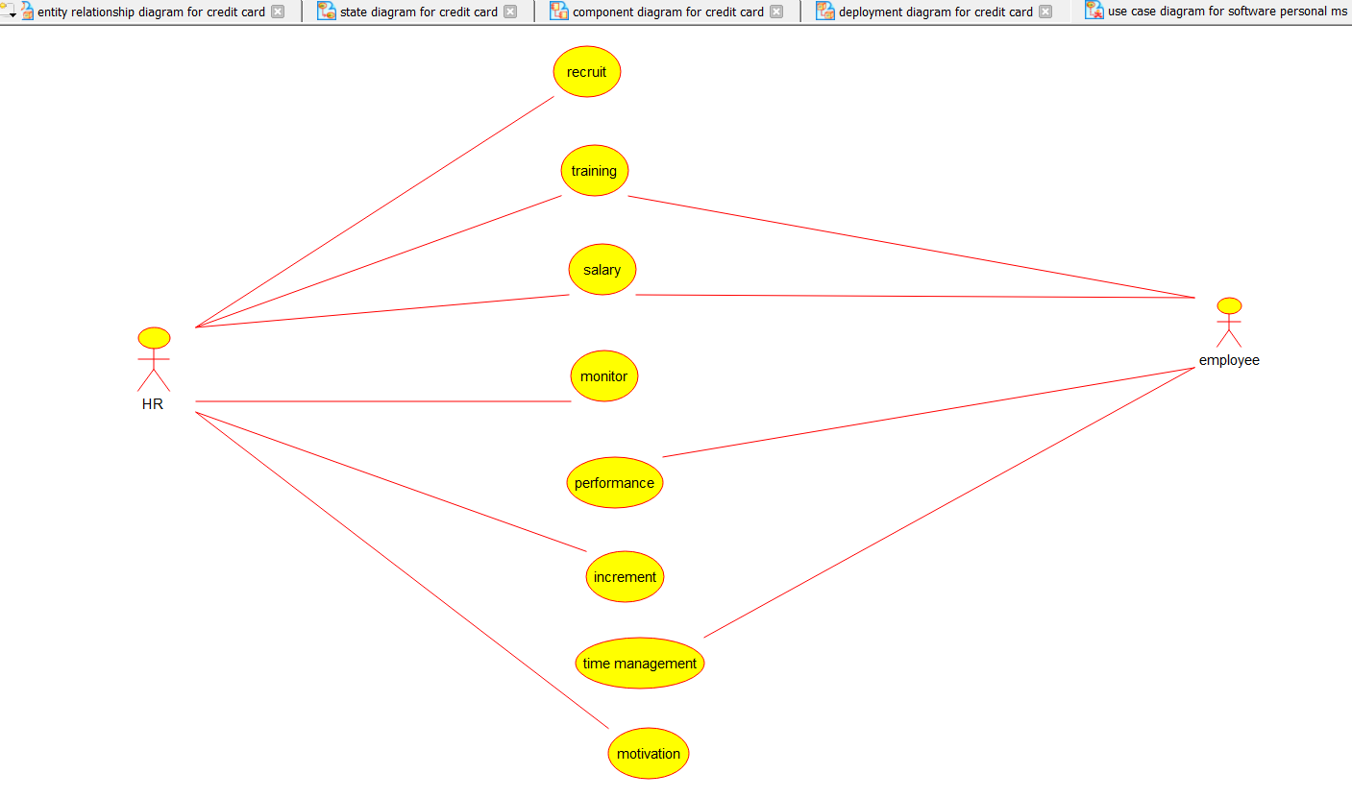

ACTIVITY DIAGRAM:

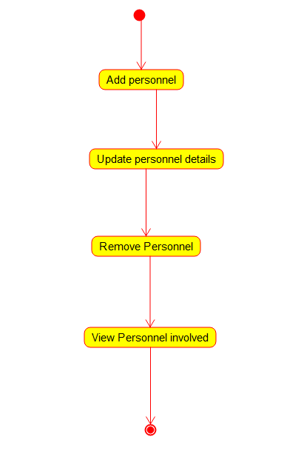

PACKAGE DIAGRAM:

